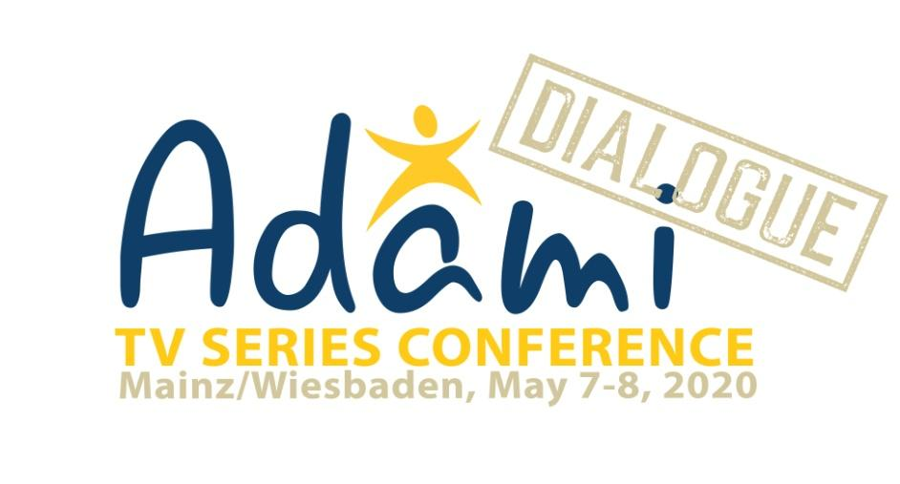

Contact:
Philomena Grassl philo.grassl@adamimediaprize.eu Tbilisi, Georgia +995555122331

!!Attention!! Considering the current situation with the spread of COVID-19, the ADAMI Media Prize wants to inform you that, if necessary, the dates of the conference will be changed. Please do not hesitate to submit applications.
Press-Release
Open Call for participants for the ADAMI Dialogue TV Series Conference

The ADAMI Media Prize for Cultural Diversity in Eastern Europe invites broadcasters and independent creative studios from the EU Eastern Partnership Countries (Armenia, Azerbaijan, Belarus, Georgia, Moldova and Ukraine) and from the EU to take part in the ADAMI Dialogue TV Series Conference, May 7-8, in the Broadcasting Center of the ZDF in Mainz, Germany.
The ADAMI Dialogue focuses on TV or Online-Series and their potential in the popularisation of Cultural Diversity and in developing a tolerant and open society.
The conference will be held in partnership with the goEast Festival of Central- and Eastern European Film in Wiesbaden, where the conference participants will have the chance to attend screenings and events. Selected series from the Eastern Partnership Countries will be presented at the festival as well.
The conference is organized in cooperation with the partnership program of the European Broadcasting Union (EBU), Seriencamp in Munich and Film Festival Cologne.

The Call for Applications is open now for participants from the Eastern Partnership Countries. For more informations and the applications form, please visit:
https://www.adamimediaprize.eu/adami-dialogue-mainzwiesbaden
