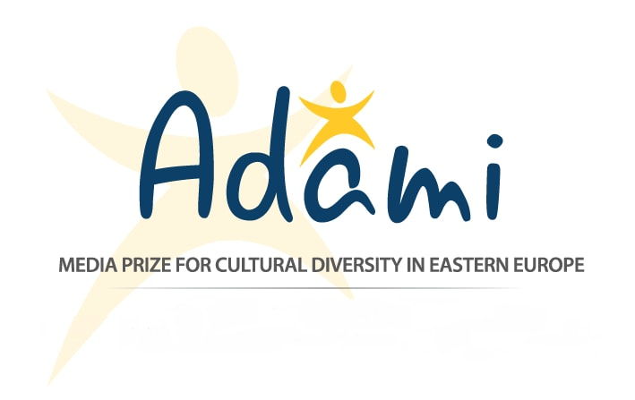

November 22, 2016
Press Release
2016 ADAMI Media Prize Gala Awards Ceremony
November 24th in Kyiv, Ukraine
For the first time, the gala awards ceremony of the prestigious ADAMI Media Prize for Cultural Diversity in Eastern Europe will be held in Ukraine, this Thursday, November 24th, 2016 starting at 16:00 (red carpet reception), at the Kyiv City Administration’s Hall of Columns. Well-known TV professionals, broadcasting executives, and senior diplomats from across Europe will be coming to the Ukrainian capital and will be attending several events.

The ADAMI Media Prize is the biggest media award for cultural diversity in Eastern Europe. It awards outstanding films, videos, and websites from the EU Eastern Partnership countries (Armenia, Azerbaijan, Belarus, Georgia, Moldova, Ukraine) that promote topics of diversity, integration, and peaceful co-existence. This year, ADAMI is also awarding one of the nominees a one-month fellowship at ARTE Journal, the news program of the French-German cultural channel ARTE. The ADAMI Media Prize initiative is funded by the Federal Foreign Office (Germany) and ProCredit Holding (Germany), and is supported by international media partners including the European Broadcasting Union, ZDF, MDR, and the national public broadcasters of Georgia (GPB), Moldova (TRM), and Ukraine (NTU).

The 2016 gala ceremony is being held under the auspices of the Secretary General of the Council of Europe, Mr. Thorbjørn Jagland, and the OSCE Representative on Freedom of the Media, Ms. Dunja Mijatović, who will be giving the opening speech at the event.

Flying in from Los Angeles, Belarusian presenter Leila Ismailova will host the event together with Gloria Gorceag from Chisinau and Ukrainian TV host Timur Miroshnychenko. The award ceremony will be broadcasted live on the National Television of Ukraine, the Georgian Public Broadcaster, and TeleRadio Moldova. The event will also be covered by Deutsche Welle, MDR Germany, and online media. An after-gala reception will follow for the black-tie event.

Journalists and photographers are welcome to cover the award ceremony. There will be a red carpet reception starting at 16:00. Please note that during the live broadcasting of the gala, press will not be allowed to stay on the floor, but can cover the event from the balcony overlooking the venue. Press are asked to please register at the following link: http://bit.ly/ADAMI-Press-Registration

The Ambassador of the Federal Republic of Germany to Ukraine, Dr. Ernst Reichel, will hold a reception earlier on the 24th of November at the Embassy of Germany for the nominees, patrons, and special guests of the gala.

As part of the ADAMI events, there will be held an ADAMI Talks panel on November 25th at 11:00, at the Taras Shevchenko National University of Kyiv, with the title "Freedom of the Media and Cultural Diversity in TV and the Internet – A Permanent Struggle?” The OSCE Representative on Freedom of the Media, Ms. Dunja Mijatović (Vienna, Austria), will be discussing with Carolin Ollivier, Editor-in-Chief of Arte Journal (Strasbourg, France). The panel with Q&A will be moderated by senior journalist and TV presenter Yuri Makarov (NTU). Journalists who want to attend may sign up at:
https://docs.google.com/forms/d/e/1FAIpQLSewdHaEpHGB_pUwjshDC0ygYt7zXe9HbohpdVmmEunK2mTahA/viewform.

-----------------------------------------------------------------------------------------------------------------------------------------
Contact: Arianne Swieca
Email: communications@adamimediaprize.eu
Web: www.adamimediaprize.eu
Tel.: +995 32 222 57 59
Facebook: www.facebook.com/adamimediaprize

ADAMI Media Prize for Cultural Diversity in Eastern Europe
c/o Swiss Cooperation Office, 12 Sh. Radiani Street, Tbilisi, Georgia 0179
An initiative of the Forschungsgruppe Modellprojekte e.V. – Babostr.3, 69469 Weinheim, Germany

