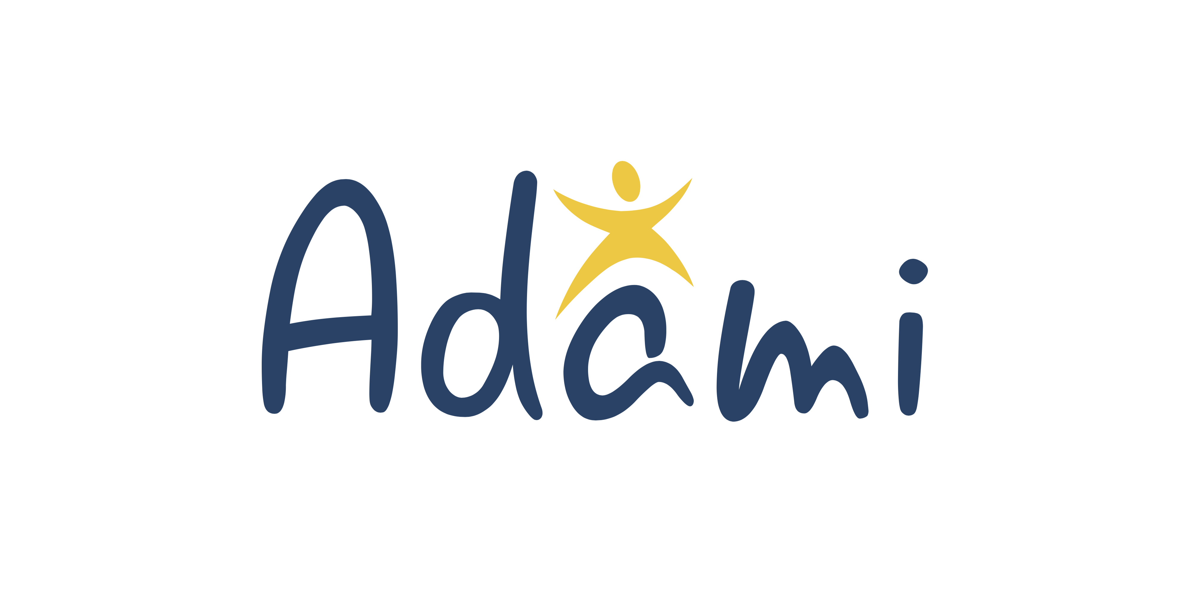
18 October 2017

ProCredit group and ADAMI Media Prize continue their cooperation to promote cultural diversity in Eastern Europe

The prolongation of cooperation between the ADAMI Media Prize and ProCredit Holding, which began in 2016, ensures the continued support of the activities of the ADAMI Media Prize in promoting cultural diversity and establishing networking opportunities for filmmakers, audio-visual journalists, and broadcasters. The countries in which the ADAMI Media Prize is active are Armenia, Azerbaijan, Belarus, Georgia, the Republic of Moldova, and Ukraine. The ADAMI Media Prize is an initiative of the German non-profit organisation Forschungsgruppe Modellprojekte e.V. and is sponsored by the German Federal Foreign Office (Auswärtiges Amt). Stefan Tolz, the Programme Director of the ADAMI Media Prize, stated: “The support of the ProCredit group helps us to drive forward the design and development of this fairly new media prize as well as its training initiatives. Cooperation is also an important sign for the civil societies in the Eastern Partnership countries that joint commitment can bring forth important ideas."

ProCredit Holding will be providing additional funding for ADAMI activities in 2017 as well as for the organisation of the ADAMI media prize in 2018, including the gala awards ceremony in Chişinău, Moldova. The internationally broadcasted event awards outstanding film, television, and online programmes that promote national, ethnic, religious, or cultural diversity among the peoples of Eastern Europe and the Caucasus.

Borislav Kostadinov, Member of the Management Board of ProCredit Holding, the parent company of the ProCredit group, said: "As a banking group that strives to act responsibly, ProCredit shares the underlying ethical principles of the ADAMI Media Prize and is convinced that the media landscape plays a key role in the sharpening of public attitudes with regard to cultural diversity, exemplifying how pluralism and heterogeneity can contribute to peaceful coexistence."

The ADAMI Media Prize focuses on the work of journalists and media professionals in the EU Eastern Partnership countries. ADAMI’s goal is to promote peaceful coexistence between peoples by stimulating new ideas and perspectives in media, and by promoting media interest in topics of cultural diversity and integration.

About the ADAMI Media Prize
The ADAMI Media Prize is an initiative of the German non-profit organisation Forschungsgruppe Modellprojekte e.V. and is funded by the German Federal Foreign Office (Auswärtiges Amt). It is organised in coordination with the European Broadcasting Union (EBU), the German Society for Eastern European Studies and is supported by media partners such as MDR, ZDF, Deutsche Welle, the French-German cultural channel ARTE, and the public broadcasting companies of Georgia, Moldova, and Ukraine. Renowned journalists and filmmakers from television and media companies across Europe are contributing their experience to ADAMI to create better working and networking opportunities in the Eastern Partnership countries and to promote diversity in the media. For additional information, visit www.adamimediaprize.eu.

About the ProCredit Group
ProCredit Holding AG & Co. KGaA, based in Frankfurt am Main, Germany, is the parent company of the development-oriented ProCredit group, which consists of commercial banks for small and medium enterprises (SMEs) and whose operational focus is on South Eastern and Eastern Europe. In addition to this regional presence, the ProCredit group is also active in South America and Germany. The company’s shares are traded on the Prime Standard segment of the Frankfurt Stock Exchange. The anchor shareholders of ProCredit Holding AG & Co. KGaA include the strategic investors Zeitinger Invest and ProCredit Staff Invest (comprising the investment vehicles for ProCredit staff), the Dutch DOEN Participaties BV, KfW and the IFC (part of the World Bank Group). As the group’s superordinated company according to the German Banking Act, ProCredit Holding AG & Co. KGaA is supervised on a consolidated level by the German Federal Financial Supervisory Authority (Bundesanstalt für Finanzdienstleistungsaufsicht, BaFin) and the German Bundesbank. More information can be found on the company’s website at www.procredit-holding.com.

Contacts
Arianne Swieca, Communications Coordinator,
ADAMI MEDIA PRIZE FOR CULTURAL DIVERSITY IN EASTERN EUROPE,
Mobile +995 599 44 52 29, communications@adamimediaprize.eu

Andrea Kaufmann, Group Communications, ProCredit Holding,
Tel.: +49 69 951 437 138: Andrea.Kaufmann@procredit-group.com

